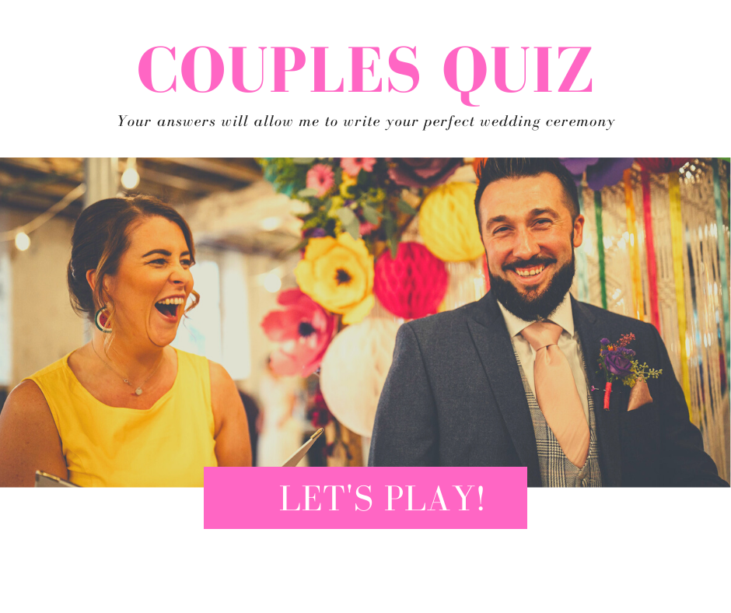

(Please complete separately)

Describe how you met

What did you think of your partner when you first met them?

Who asked whom out, and how?

How would you describe your partner?

How would they describe you?

When did you first know you loved your partner?

What are your partner’s best traits?

And their worst?

Tell me the story of your proposal…

What is the secret to your great relationship?

What challenges have you faced as a couple?

Do you have children? Tell me how they came about ( age not details haha ) and how they’ve changed your life and your relationship.

What’s the biggest thing your partner has taught you?

What do you love most about your partner, give as much detail as you like?

Why do you think you work so well as a couple

Tell me some things you enjoy doing as a couple or family.

What are some key moments in your relationship you remember?

Are there any significant moments, funny moments, tough times you have been through that you'd like mentioned in the ceremony?

What does you partner do that always makes you smile?

Why do you want to be married to them?

What’s next for you as a couple?

