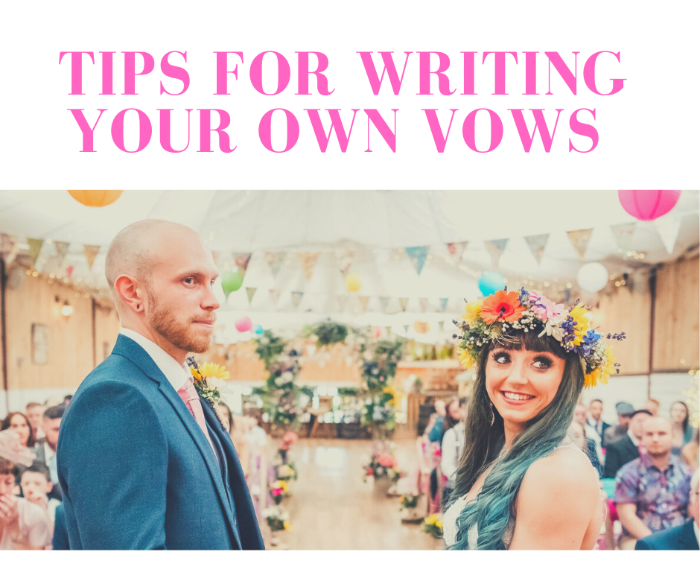

Writing your own vows might seem scary, but it’s easier than you think.

Grab a pen and jot down what springs to mind when you ask yourself these questions.

- When did you know this was "the person for you"?

- How does your partner make you feel?

- What impact does your partner have on your life?

- What personality traits does your partner have that compliments yours?

- What do you work the most on in your relationship?

- Has your partner changed your life? How?

- What do you love most about your partner?

- Why do you think your relationship works so well?

- What are your hopes for the future?

Still struggling? Here’s some different types of example vows for inspiration.

Civil Vows
If you have a ceremony with a registrar, these are the vows you will be asked to repeat to cement your legal marriage.

I declare that I know of no legal reason why I (your name) may not be joined in marriage to (your partner's name).

I call upon these persons, here present, to witness that I (your full name) do take thee (your partner's full name) to be my lawful wedded wife/husband.

Traditional church vows :

Do you take [name] to be Your husband,
to have and to hold from this day forward for
better or for worse,
for richer or for poorer,
in sickness and in health,
to love and to cherish until death do
you part

How about adding in a little bit of humour?

I promise to always leave the
lights on in the bathroom
I promise to mysteriously take
three hours to make a simple omelet
I pledge to listen to your advice,
and occasionally take it
I pledge to never take score...
even if I'm totally winning
I believe there is no time or place I'm more
content than when you're close
Because of this and so, so much more...
I believe that I will always love you

How about mixing sweet with hints of funny?

I promise to forget to stack the dishes on the
right and leave stagnant water in the sink
I promise to always drive the speed limit,
even on the freeway
I promise to cuss loudly at video games
I vow to snuggle you as often as possible
I vow to make you really really laugh out loud
I vow to always try one bite
of any meal you create
I vow to be the best parts of me that fit
perfectly with the best parts of you
Although I will be imperfect,
I pledge to be sensitive and
respectful of your unique talents,
abilities and quirks
I pledge to lend you strength
for all of your dreams
Together we can accomplish
more than we could alone
I love you
Or Keep it Simple
I promise to love you, always.

Take inspiration from your favourite movie or tv show

“I vow to help you love life, to always hold you
with tenderness and to have the patience that love
demands, to speak when words are needed and to
share the silence when they are not, to agree to
disagree on red velvet cake, and to live within
the warmth of your heart and always call it home.”

“I vow to fiercely love you in all your forms, now
and forever. I promise to never forget that this
is a once in a lifetime love. And to always know
in the deepest part of my soul that no matter what
challenges might carry us apart, we will always
find our way back to each other"

"We promise to love each other even when we hate
each other. No running ever. Take care when old,
senile and smelly. And it's forever"

"So it’s not going to be easy. It’s going to be
really hard. And we are going to have to work at
this everyday. But I want to do that because I
want you. I want all of you, forever, everyday"

SOME FINAL WORDS OF ADVICE
Your vows shouldn't be something you worry about and stress over. But if you're struggling to think of something to say in front of all those guests, then my advice is this.

Keep It Simple

Tell them why you are standing there, committing to a life together, and add in an I love you.

Keep It Real - Don't over complicate it, or get all emotional if that's not you. Your vows should
be said in your normal tone of voice, and be in line with your personality, after all, that's part
of the reason your partner chose you!

Avoid in jokes - As much as you two find something funny your whole family will hear these vows and you don't want awkward silences instead of laughter.

Practice makes perfect! Once you've written the vows read them a few times aloud so you don't stumble on the words during the big day!

And finally... Relax and have fun with them! It's only words.

If you’re still struggling with putting pen to paper then drop me a message to arrange a one to one chat and I’ll happily help you to create truly your meaningful vows.

